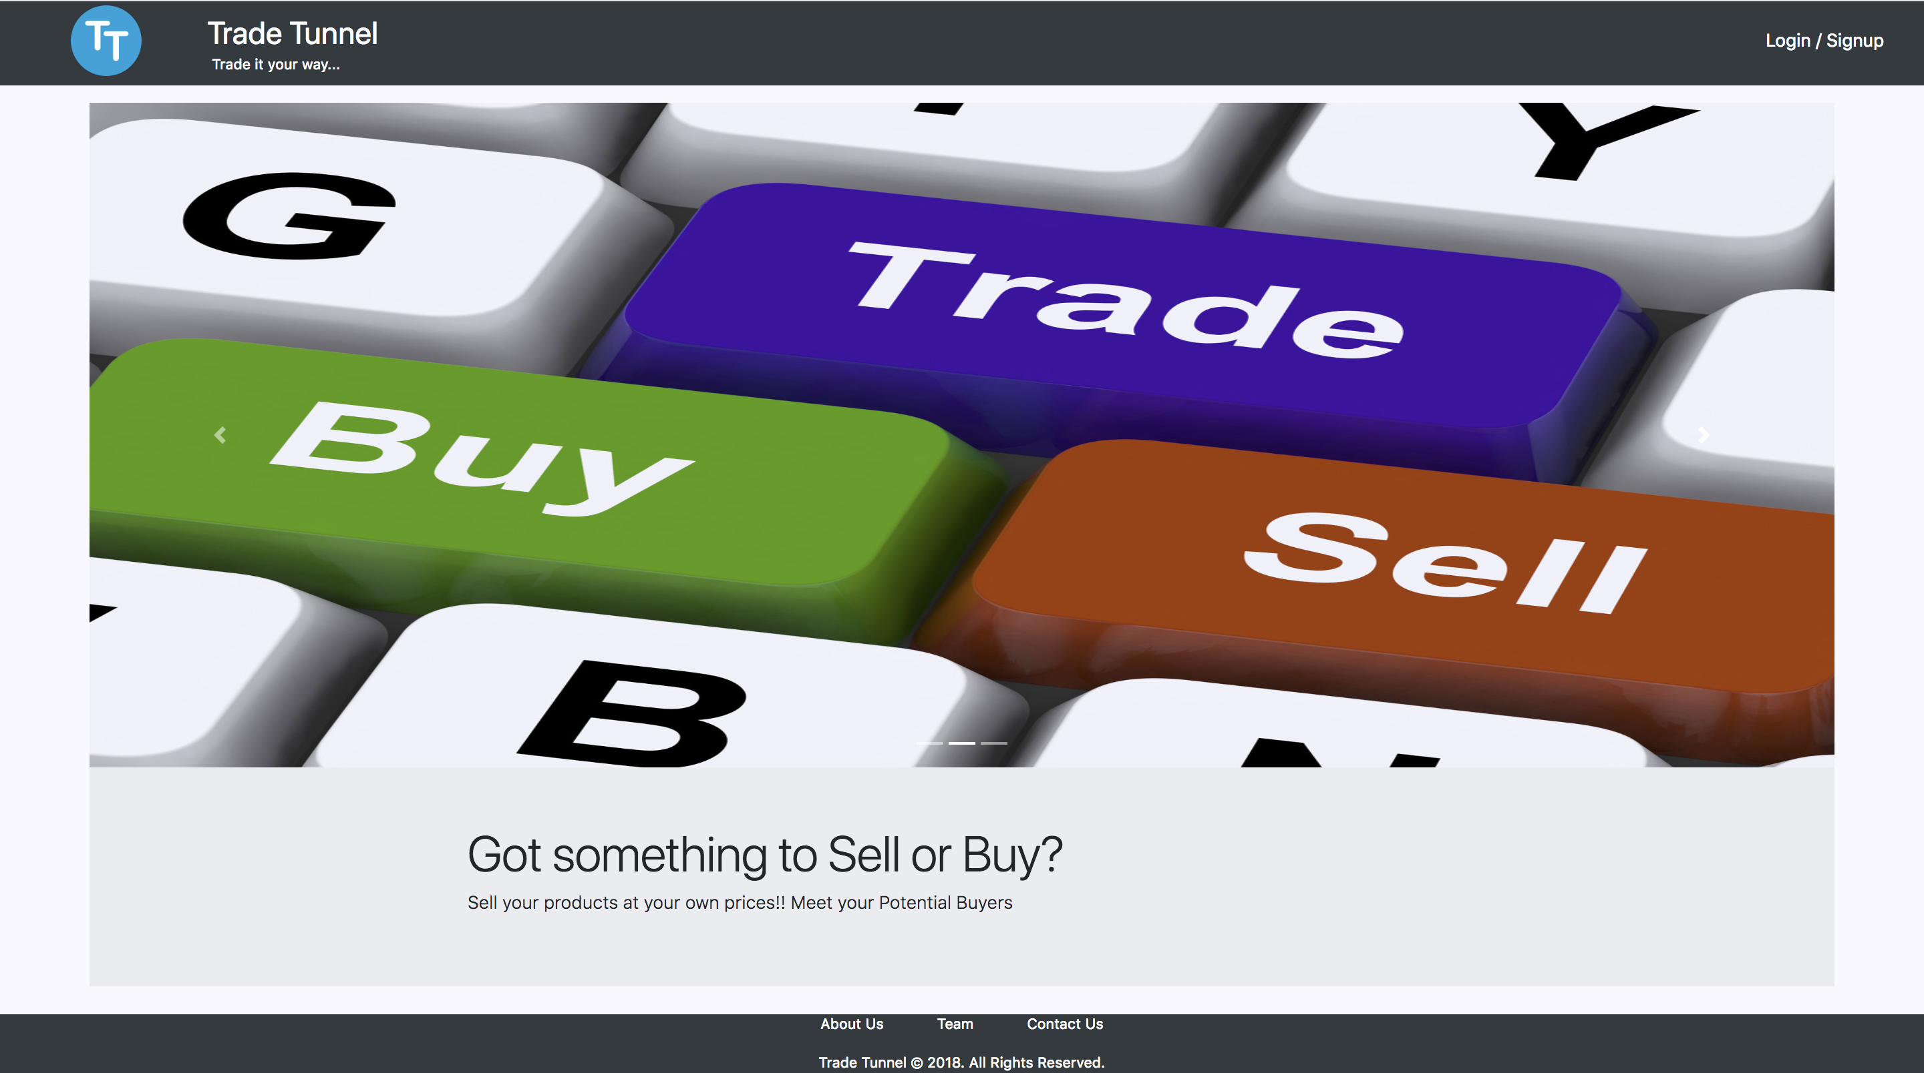

Trade Tunnel

ReadMe File And User Guide

CSE 686 – Internet Programming

Prof. Edmund Yu

Documentation provides information about the procedure to be followed for the Installation of the System. It also serves as a user guide describing system essentials

Table of Contents

Installation Guide (Tech Guide) 1

System Requirements 1

Tomcat Installation 1

MySQL COmmunity server installation 1

Deploy Web Archive and Client Application on Tomcat Server 2

User Guide 3

1. Register / Login into Application 3

2. Home Page 5

3. BRowse and Buy products 5

4. Advance Custom Search 7

5. Filter products 7

6.Sell Products 8

7.User Profile and product history 9

8. Logout from the application 11

# **Installation Guide (Tech Guide)**

This section provides detailed information on steps required for installation and environment set up to bring the web application live, up and running

## System Requirements

1. Web Browser (Google Chrome Version 66.0.3359.139 (Official Build) or higher)
2. Tomcat - Version 8.5.x or higher
3. MySQL Community Server - Version 8.0.11 (Windows user should download MSI installer , Mac OS user should download DMG Archive)
4. MySQL Workbench – Version 6.3.10

## Tomcat Installation

1. Install Tomcat - Version 8.5.x or higher follow the installation procedure as directed on the same website.
2. Make sure that tomcat is running on port 8080
3. To start and stop the server browse to the downloaded folder, navigate to the bin folder

* Mac OS users use the following scripts to start and stop the tomcat server running at port 8080

./startup.sh

./shutdown.sh

* Windows users use the following scripts to start and stop the server

run startup.bat

run shutdown.bat

1. It is Recommended to integrate tomcat with eclipse IDE for quick start and stop options with convenience to view logs

## MySQL COmmunity server installation

1. Make sure that the MySQL server is installed on port 3306, the server starts up on machine boot
2. Configure the username = root
3. Configure the password = test
4. Run the following scripts in the specified order

* SchemaScript.sql – to create the database
* Ref_Instance_Data.sql – to populate instance data for user to explore as well as the reference metadata

## Deploy Web Archive and Client Application on Tomcat Server

1. Make sure Tomcat is up and running at 8080, make sure the database is up and running at 3306 as suggested in steps above
2. To Deploy the web archive(tradetunnel-api-0.0.1-SNAPSHOT.war) on the tomcat server, follow the below steps

* Hit localhost:8080 to launch Tomcat Server GUI on your browser, Click on Manager App and login using your credentials
* Choose the provided tradetunnel-api-0.0.1-SNAPSHOT.war file and click on deploy as shown in the image below, on successful deployment, the server starts the application, this can be seen on the green section in the image below

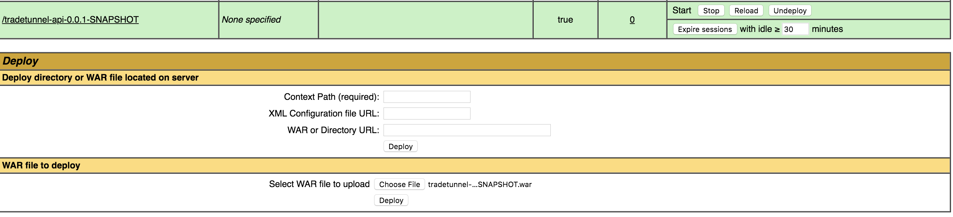

1. To Deploy the Front-End Client application, navigate to the downloaded tomcat folder, go to the webapps folder. Copy the tradetunnel Folder as provided to this location. DO NOT CHANGE THE FOLDER NAME, it is used as a context path by tomcat server
2. Navigate to <servername>:8080/tradetunnel eg: localhost:8080/tradetunnel and press enter(return) key to launch the website

# User Guide

This section describes several Use Cases and provides detailed information on how to use the Web Application

## 1. Register / Login into Application

* As shown in the figure 1.1 click on the Login/Signup Button to sign into the Web application.

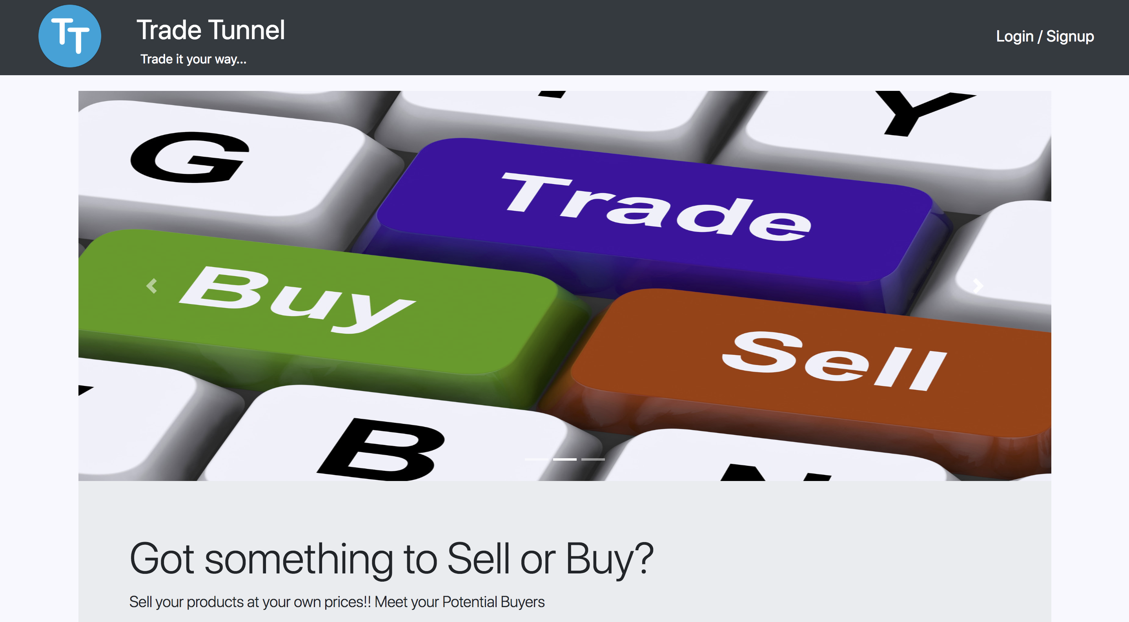

Figure 1.1

* Enter the user credentials as shown in the figure 1.2 and click on Sign In button to get started

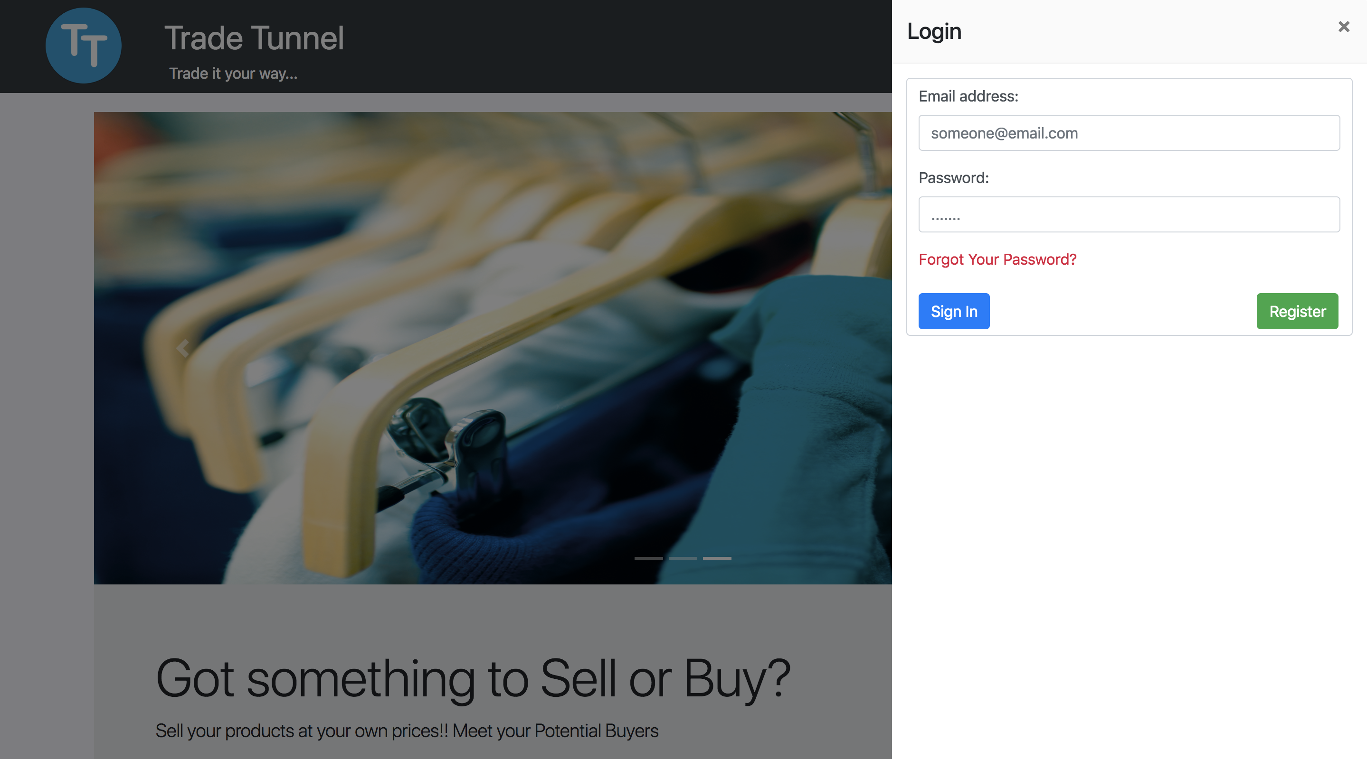

Figure 1.2

* Click on the Register button to sign up, as shown in the figure 1.3 fill up the required details and click on the Submit button to get started

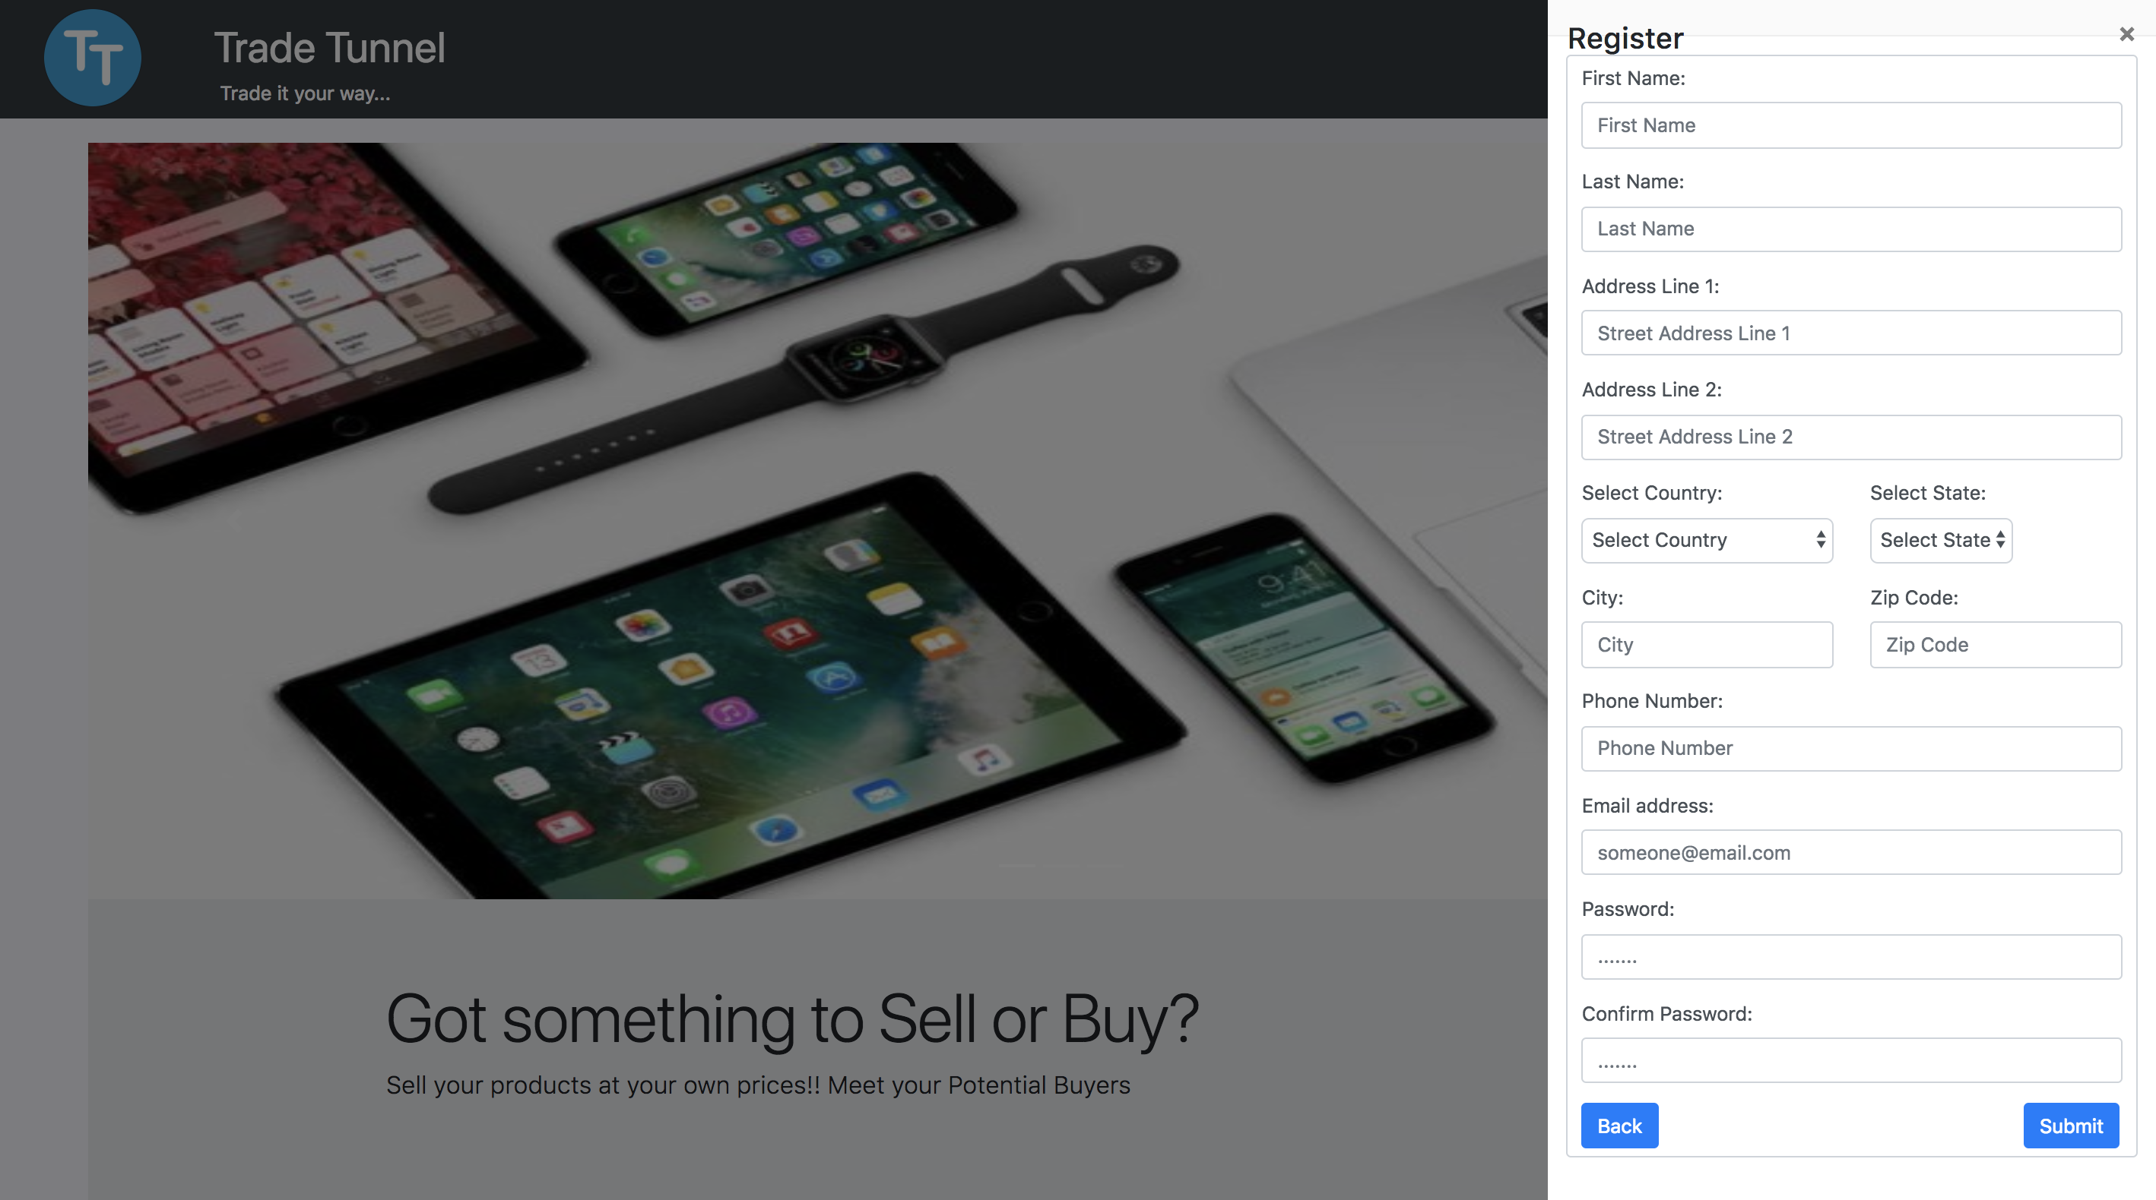

Figure 1.3

## 2. Home Page

* On successful Login, user is redirected to the home page as shown in the figure 2.1
* User can click on the Buy button, if the user wishes to purchase some products
* User can click on the Sell button, if the user wishes to advertise and sell products

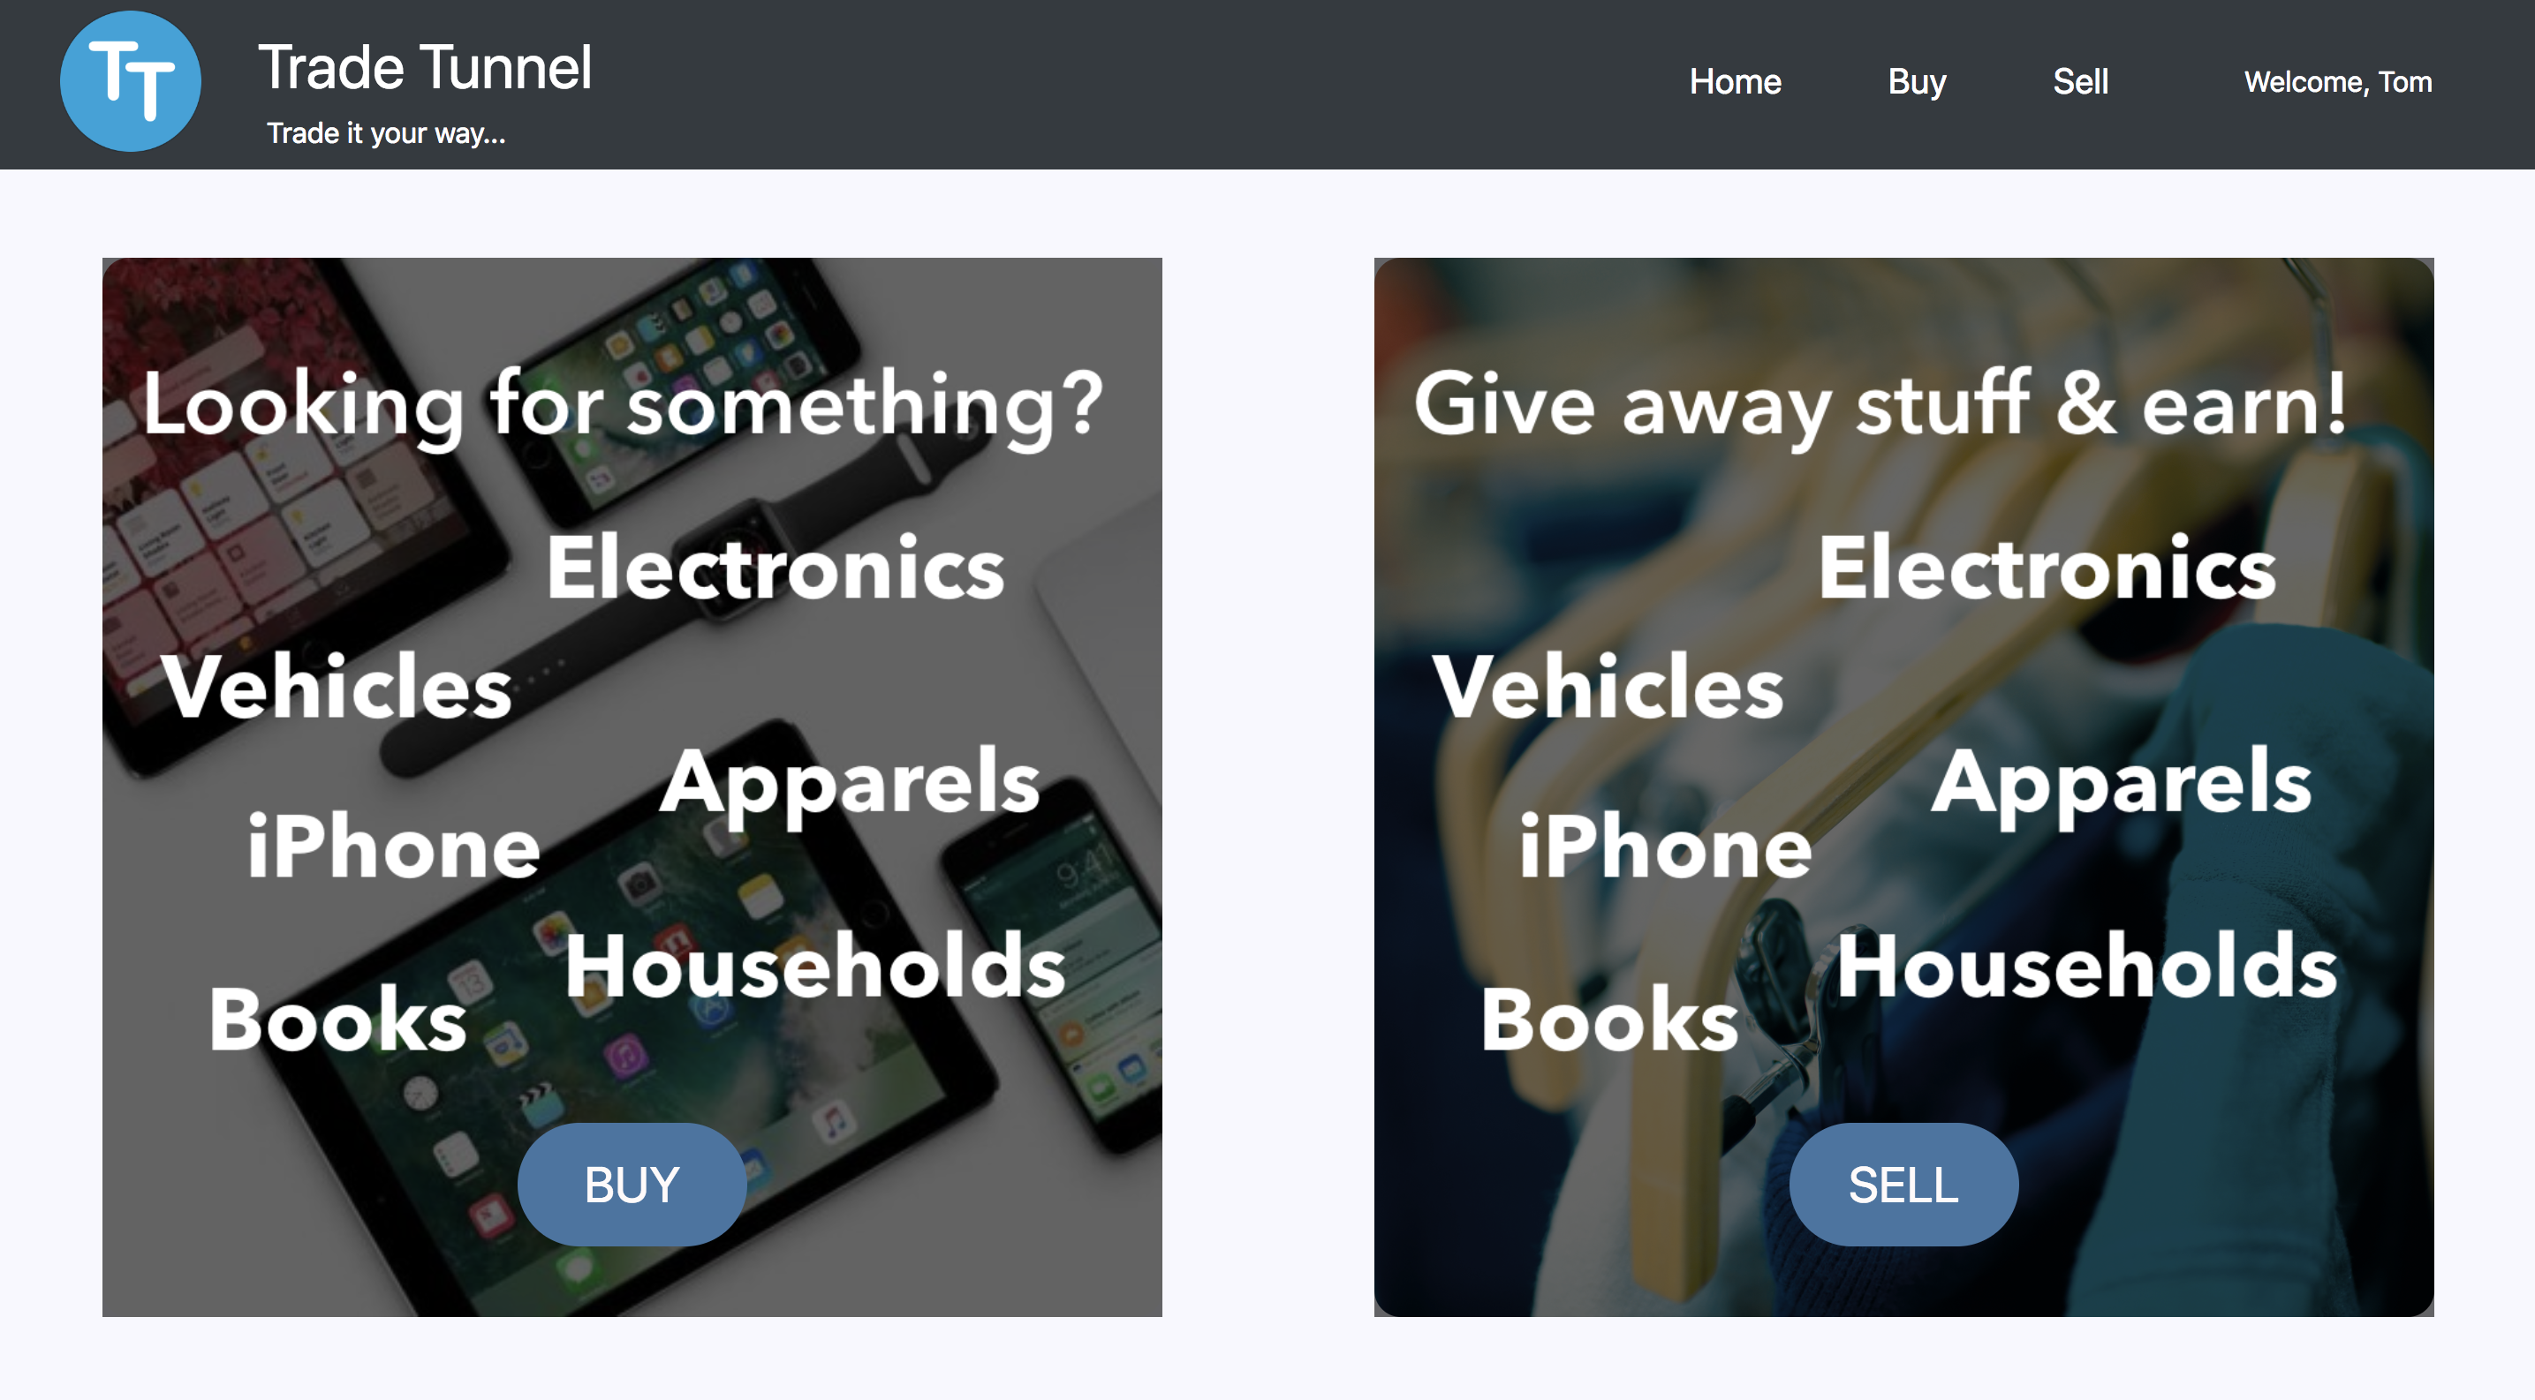

Figure 2.1

## 3. BRowse and Buy products

* On Clicking on the Buy button as shown in figure 2.1, the user is redirected to the buyer’s page.
* User can seamlessly browse through all the products as shown in figure 3.1
* The Navigation bar allows the user to directly navigate to the Buy, Sell and Home Pages.

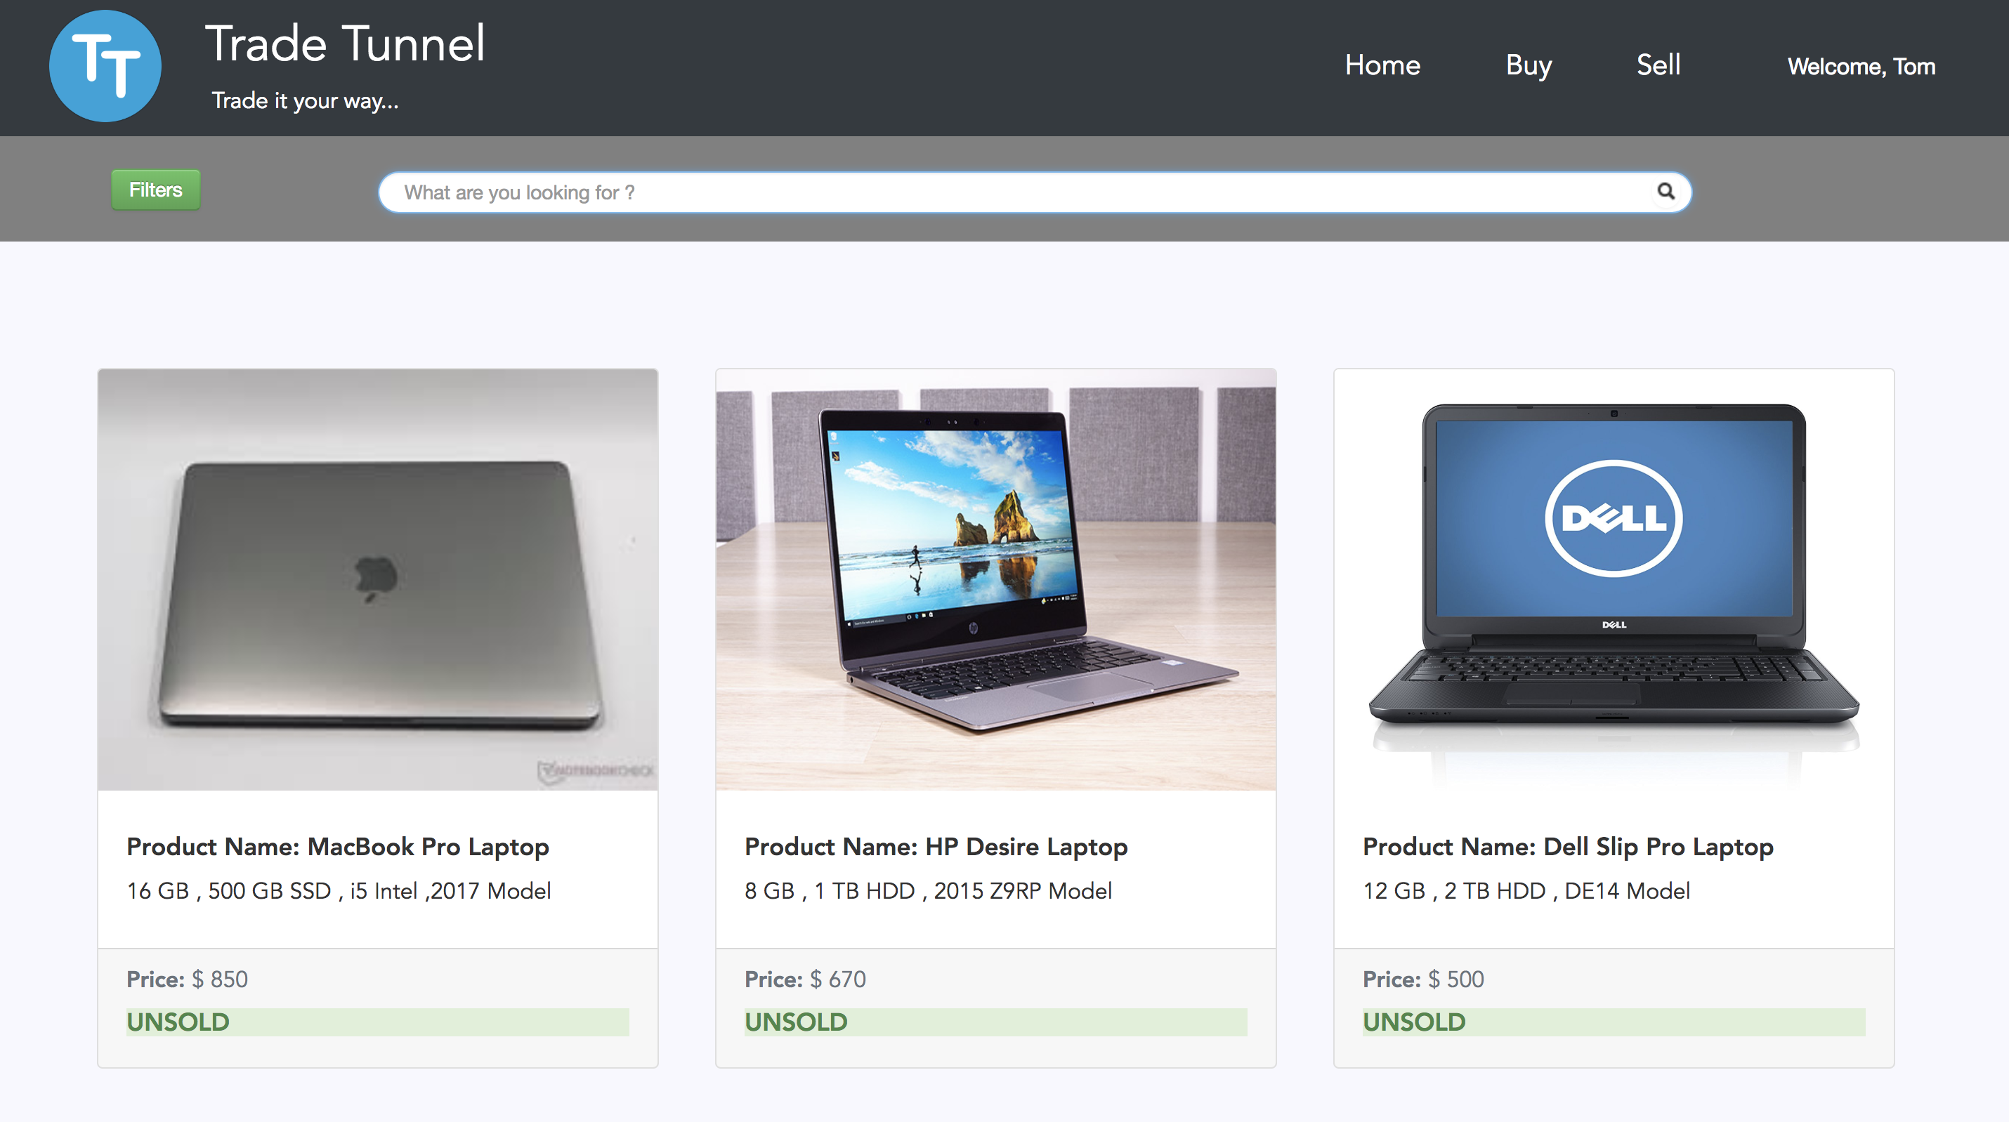

Figure 3.1

* User can click on any product of choice and view the product details as shown in figure 3.2

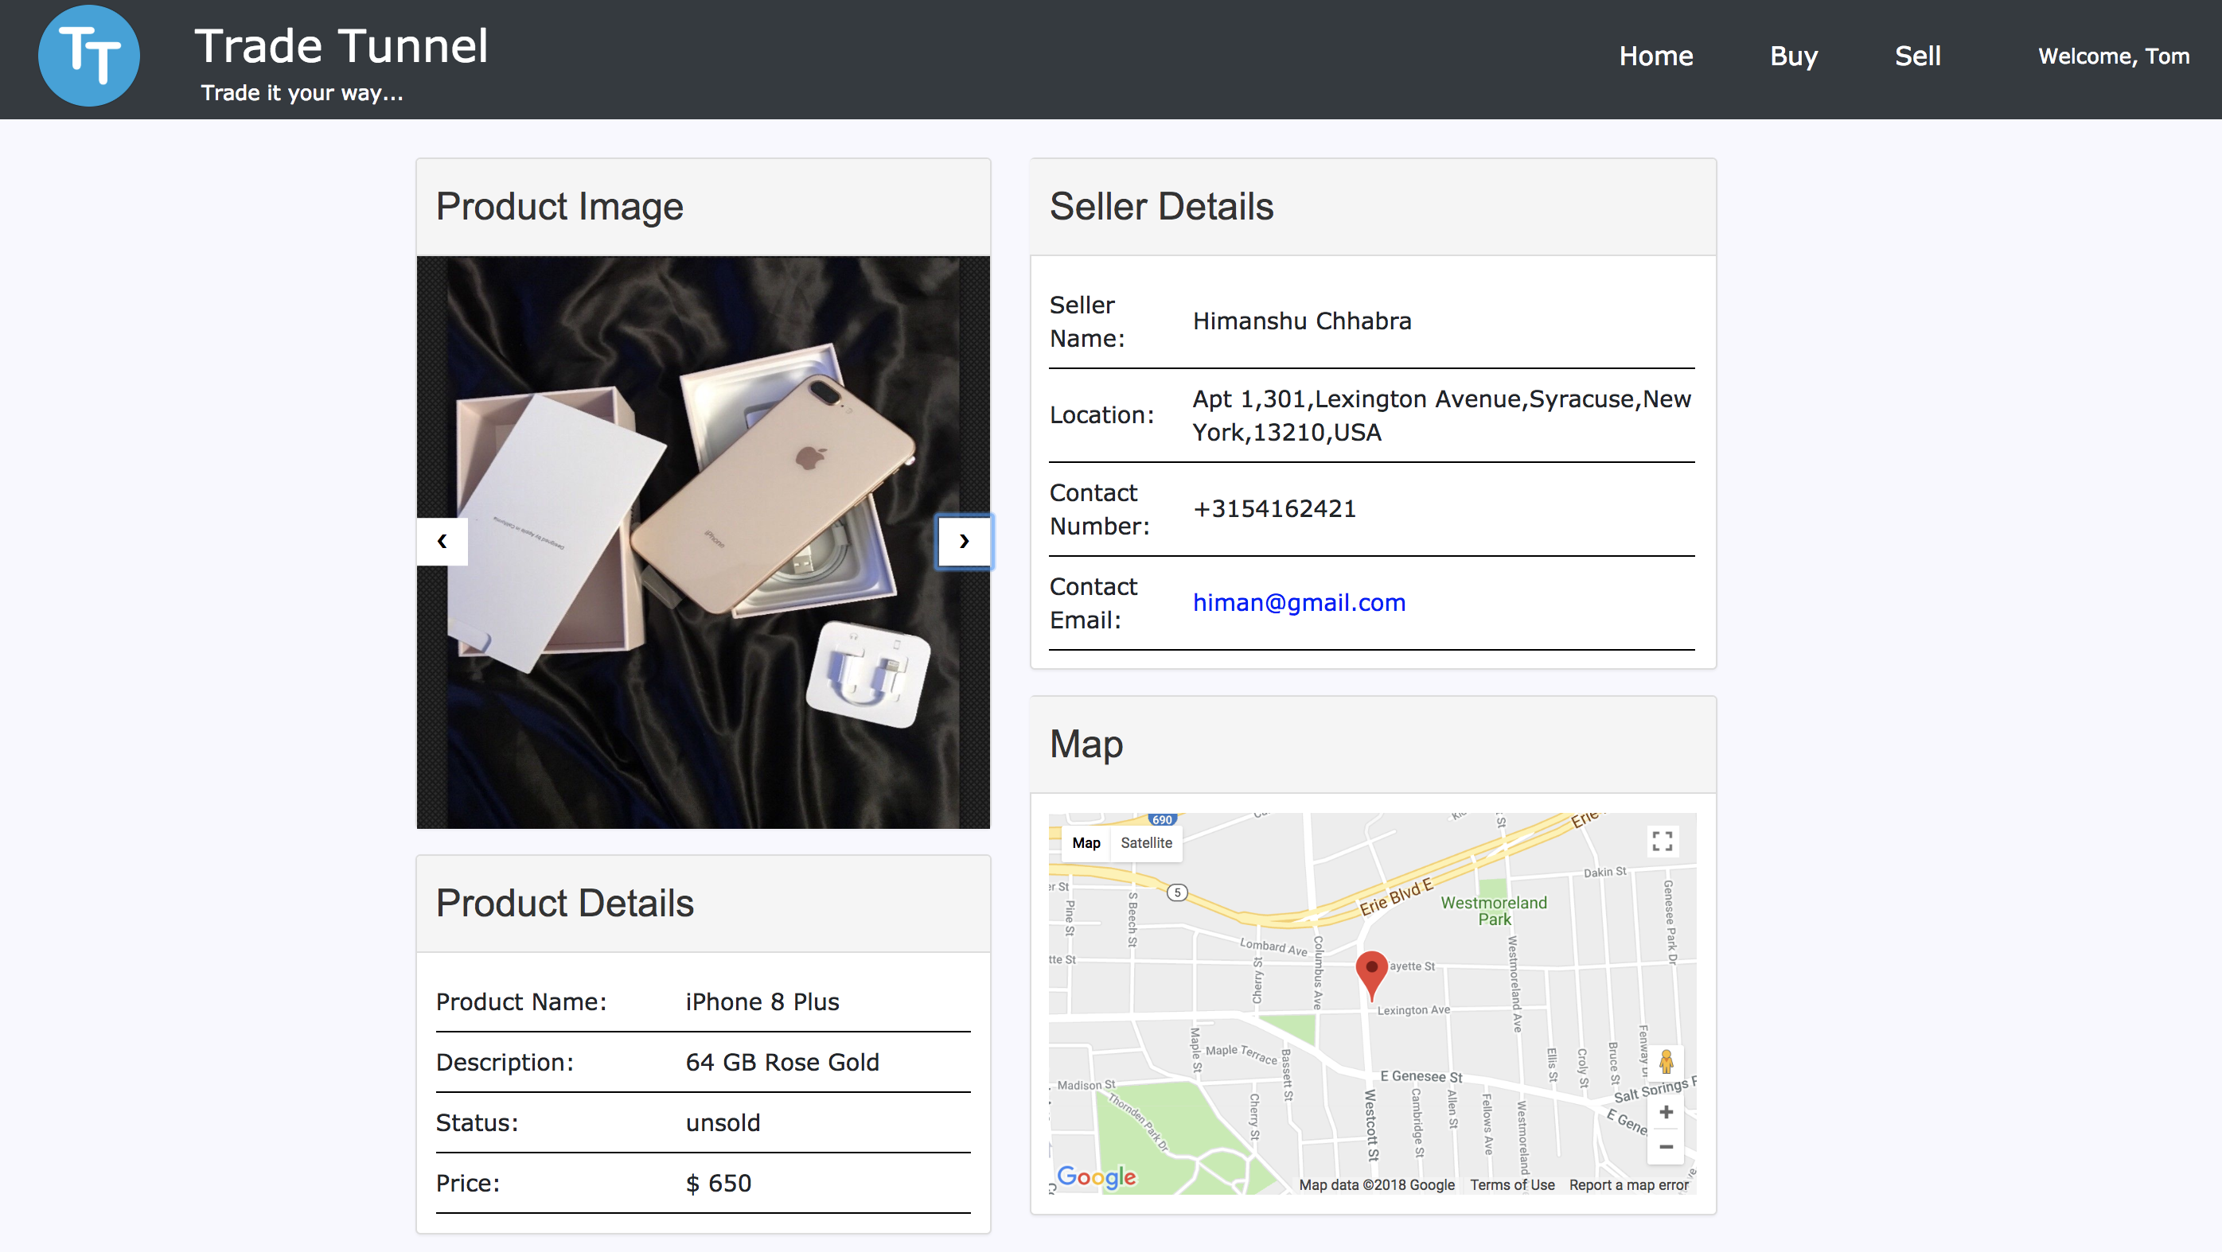

Figure 3.2

* The product’s page, allows the user to view all the images of the product and view its information in detail which includes product’s description and its price as shown in figure 3.2
* The user can also view seller’s information which includes, sellers name, location, email id and contact number as shown in figure 3.2
* The Map on the page, helps to locate the seller of the product on google maps.
* On clicking on the map, user is redirected to google maps, to help the user to identify the suitable route to the seller.

## 4. Advance Custom Search

* Custom Search assists the user to search for the products on the website using keywords as shown in the figure 4.1
* The user can simply click on the product of choice and view its detailed information

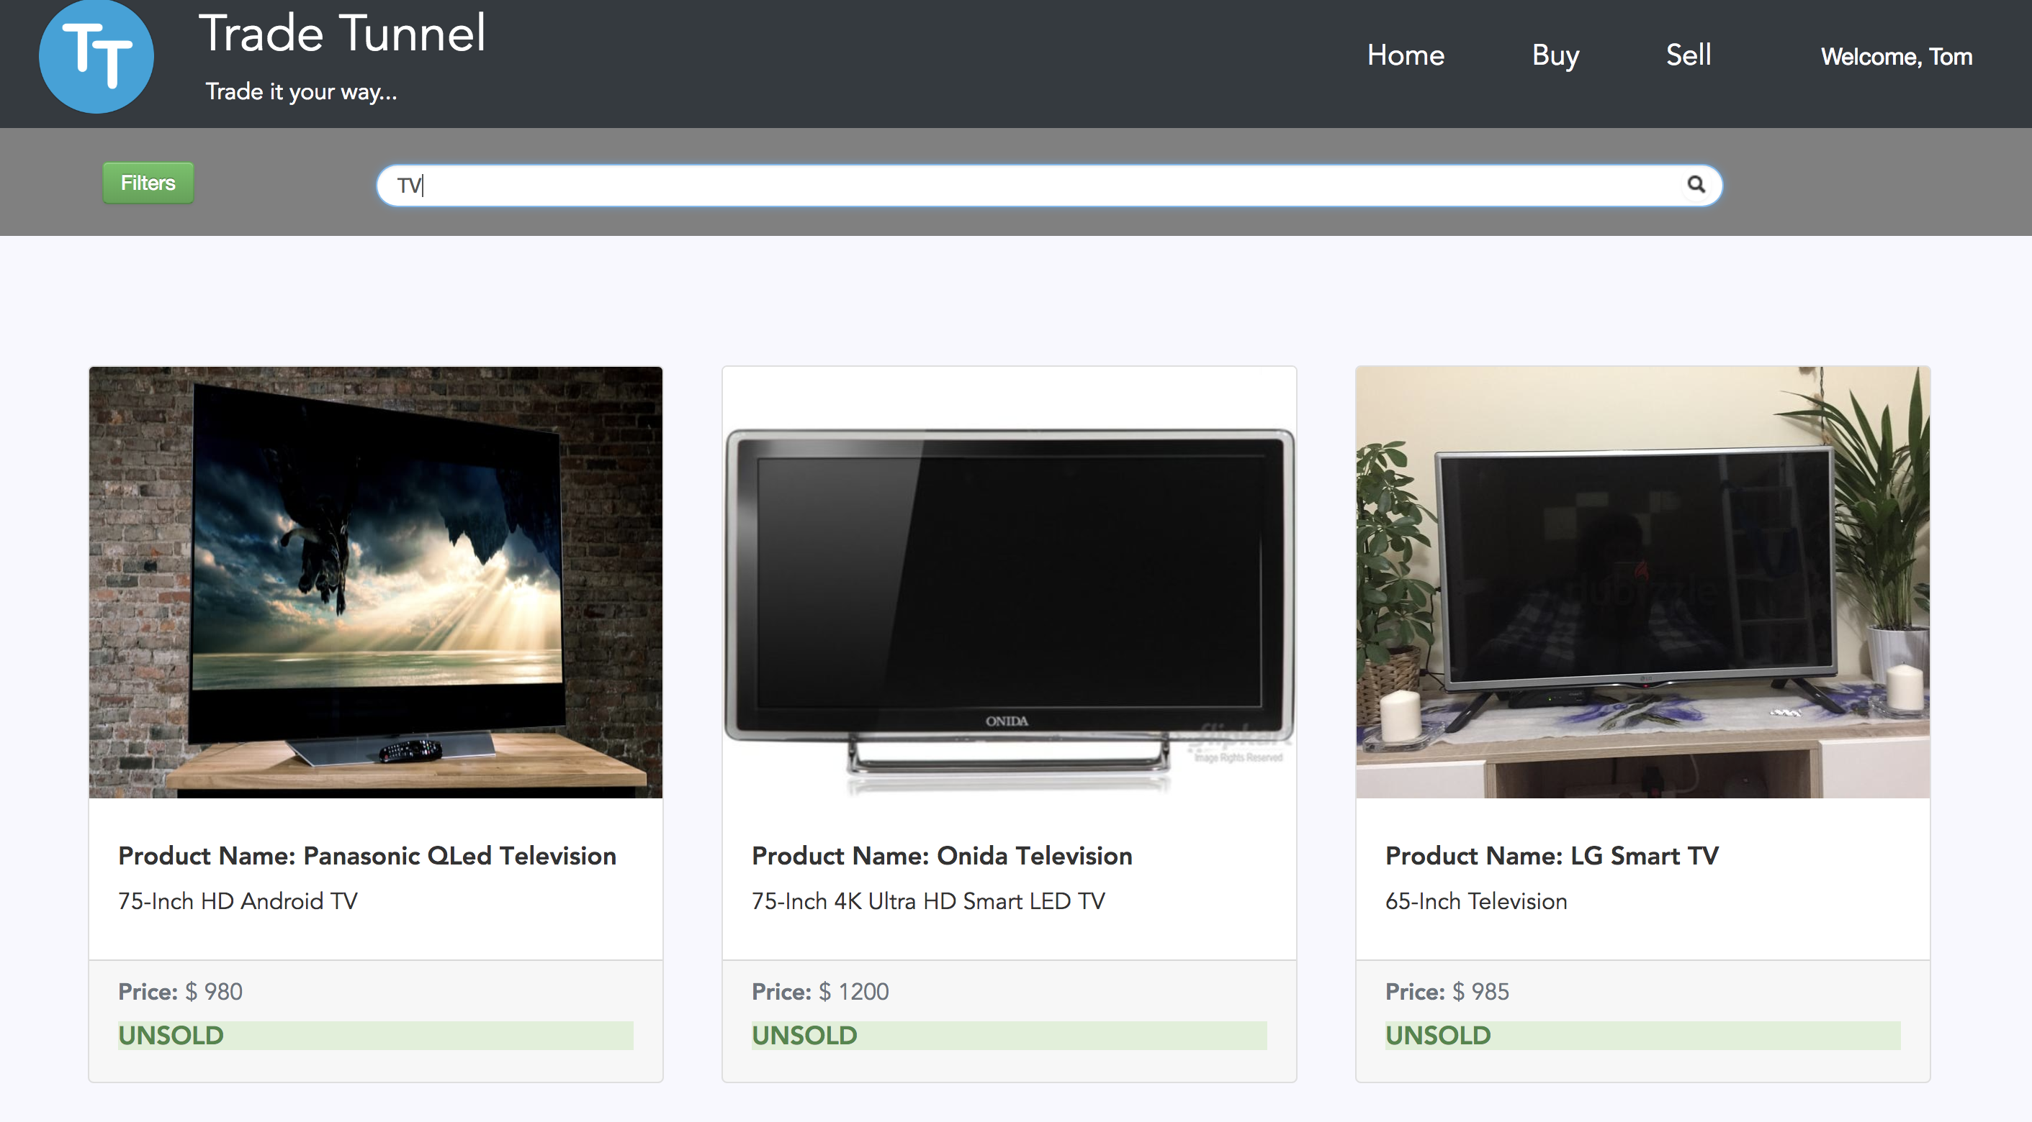

Figure 4.1

## 5. Filter products

* User can filter the products using several options provided as shown in the figure 5.1 below by clicking the filter button as shown in figure 3.1
* Categories - allows the user to filter products based on categories
* Sub-categories - allows the user to filter products based on sub-categories.
* Price range - allows the user to filter products within the price range.
* Location based service - allows the users to view products at a particular   location.
* These filters can be used in conjunction providing better user experience.

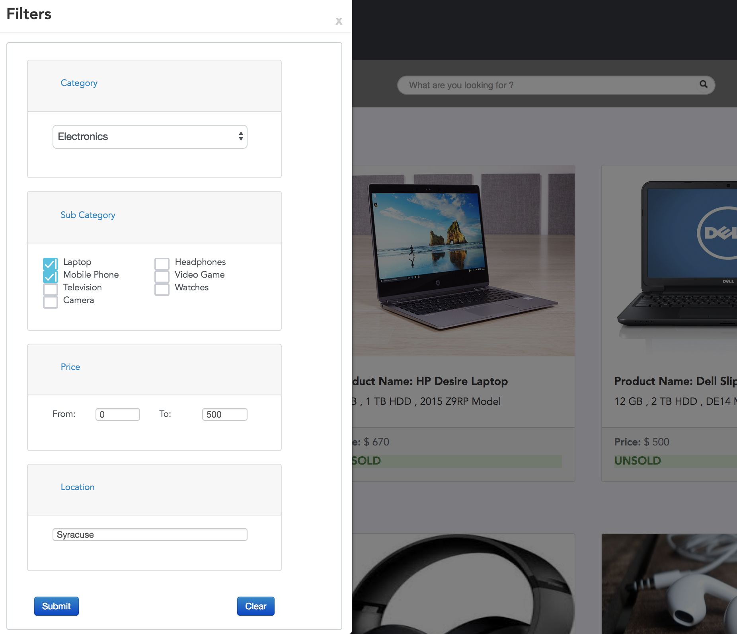

Figure 5.1

## 6.Sell Products

* User can advertise the products on the application to sell them.
* User can navigate to the seller’s page buy clicking on the Sell button as shown in figure 2.1 or buy clicking on the sell option on the navigation bar
* User Can advertise the products by providing a product name, product description and a competitive cost as shown in the figure 6.1
* The Application assists the user to set a competitive price for the product by providing with an average price of all products which fall under the selected subcategory
* User can categorize and sub-categorize the products for efficient search of the product
* Application allows the user to upload several product images as shown in the figure 6.1, the user Tom has uploaded 2 images for the product Macbook Pro.
* Reset button, clears all the fields of the form

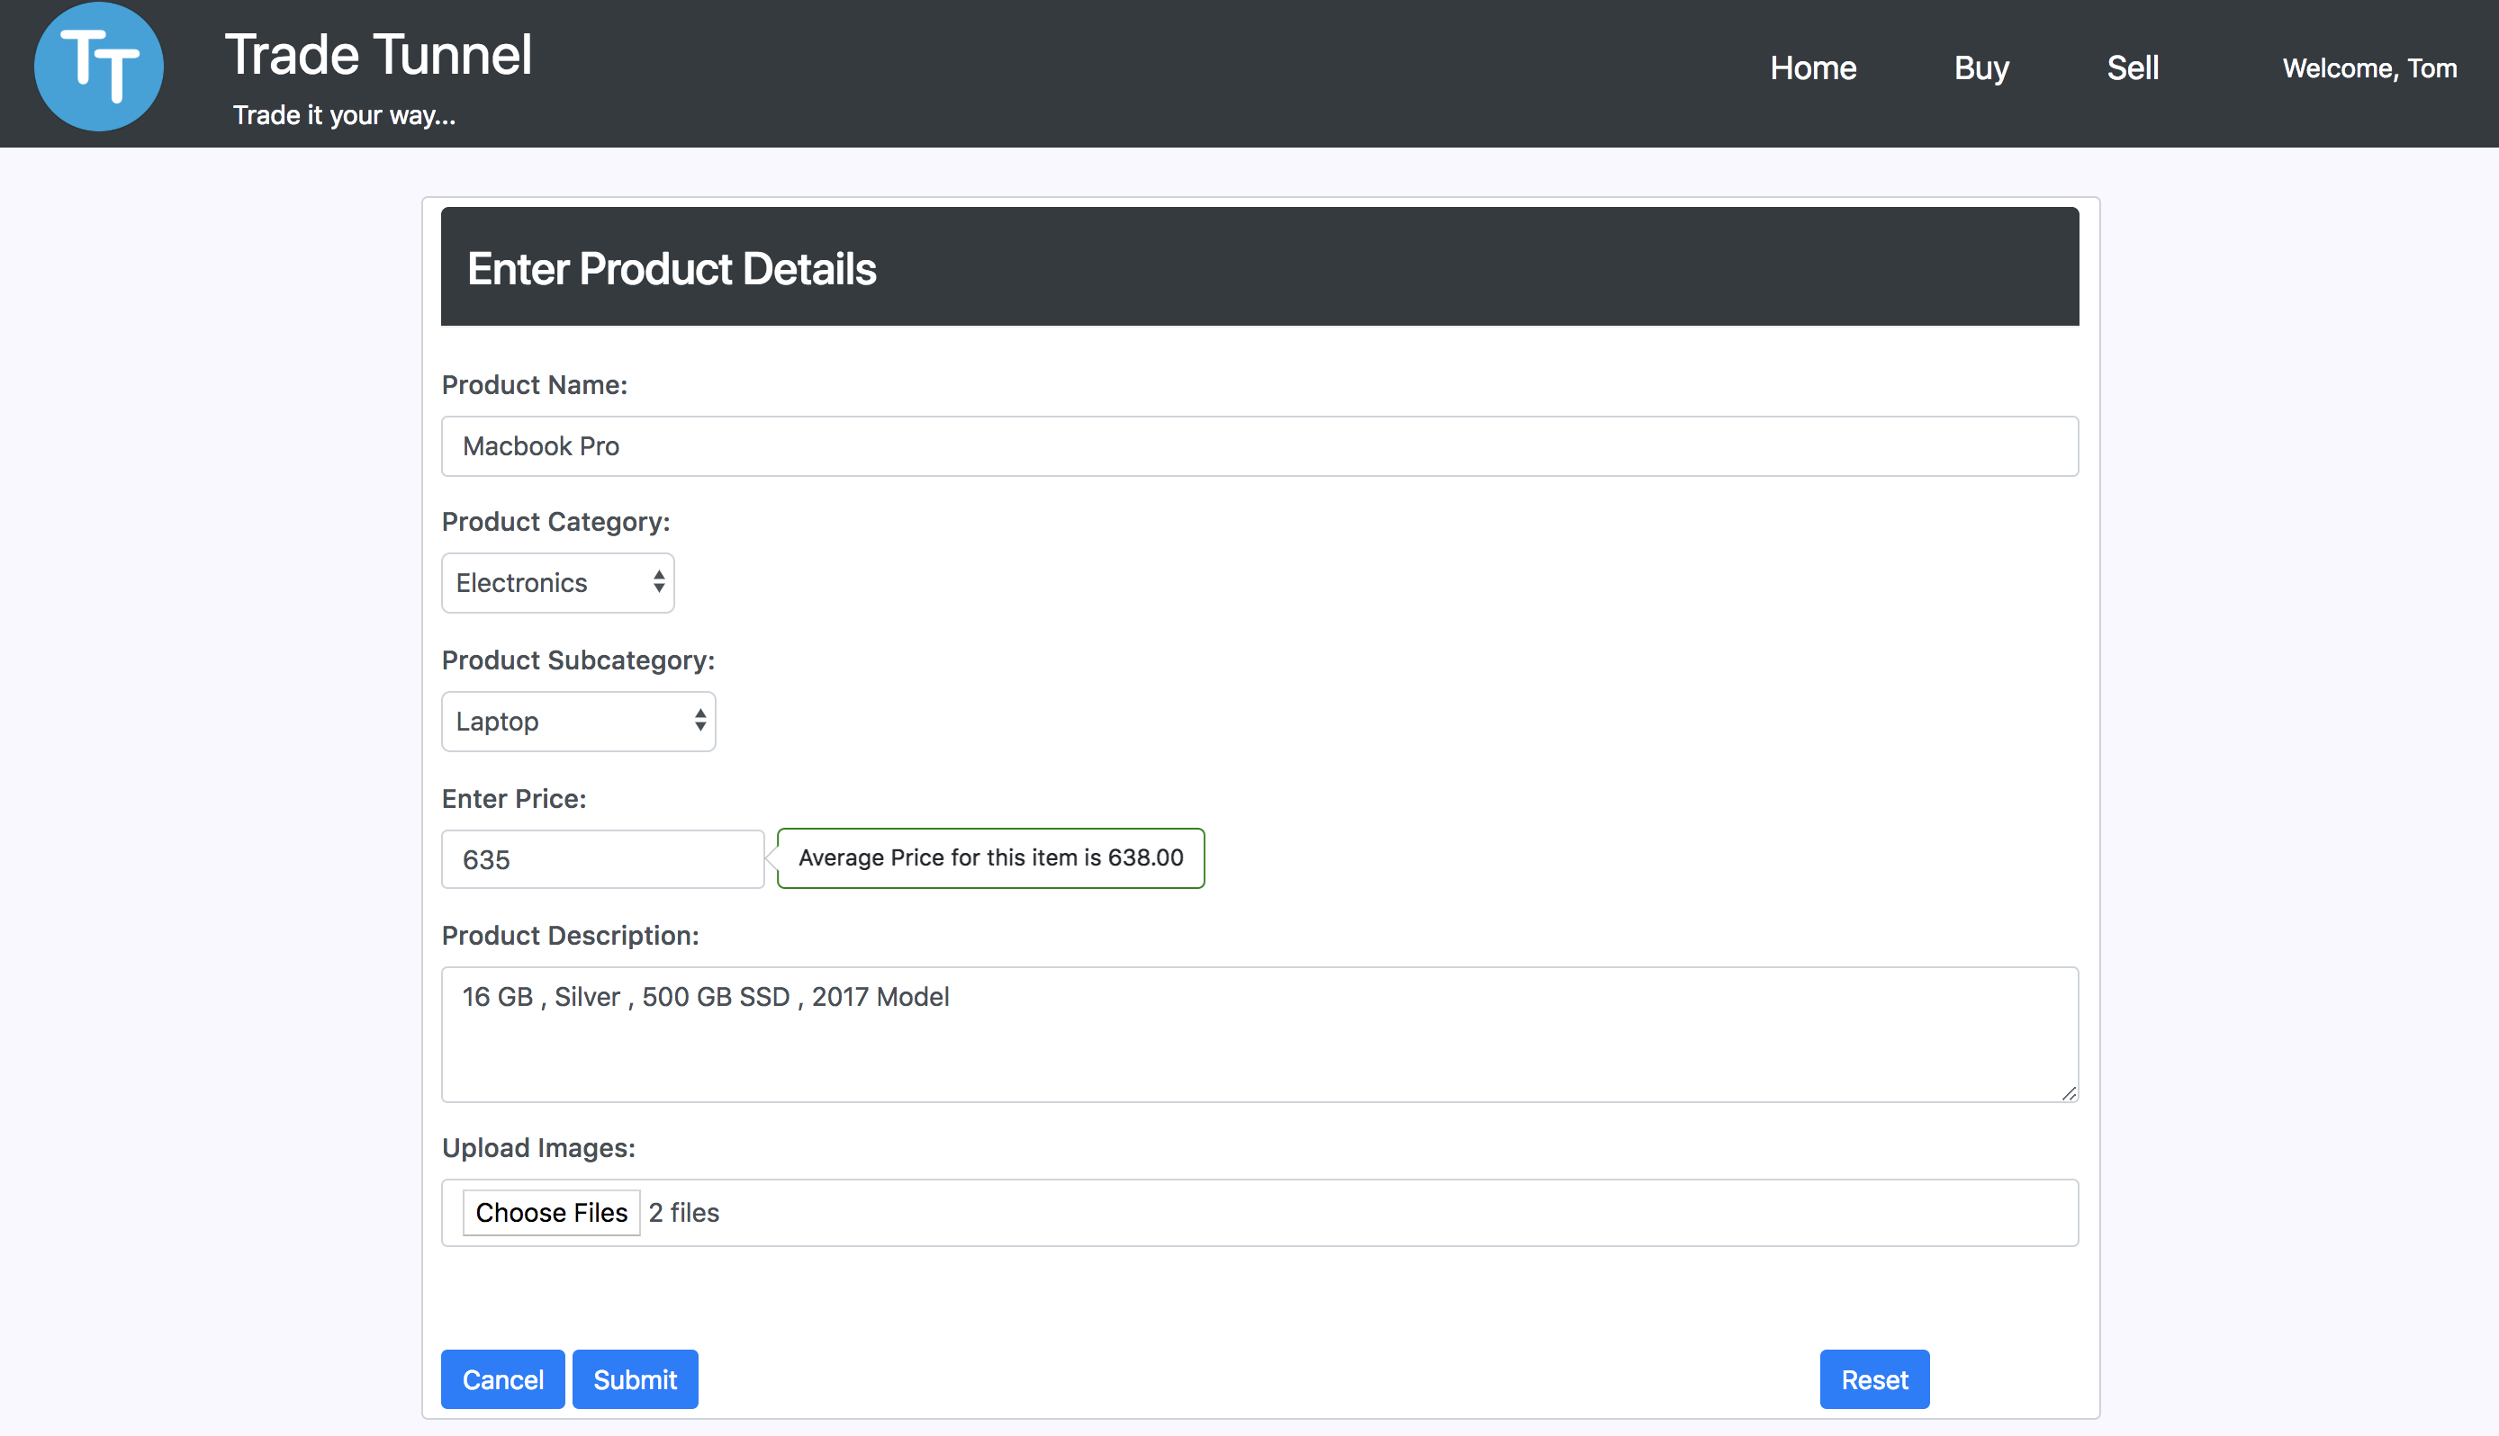

Figure 6.1

## 7.User Profile and product history

* On clicking on the Welcome Legend, the user is provided an option to view its account information or to logout of the system as shown in figure 7.1

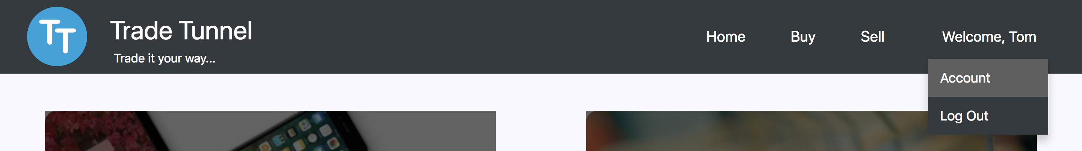

Figure 7.1

* User can Navigate to the user profiles page by clicking on Account option as shown in the figure 7.1
* On selecting my profile option as shown in figure 7.2, the user can view and/or update its personal information by clicking on the edit button.

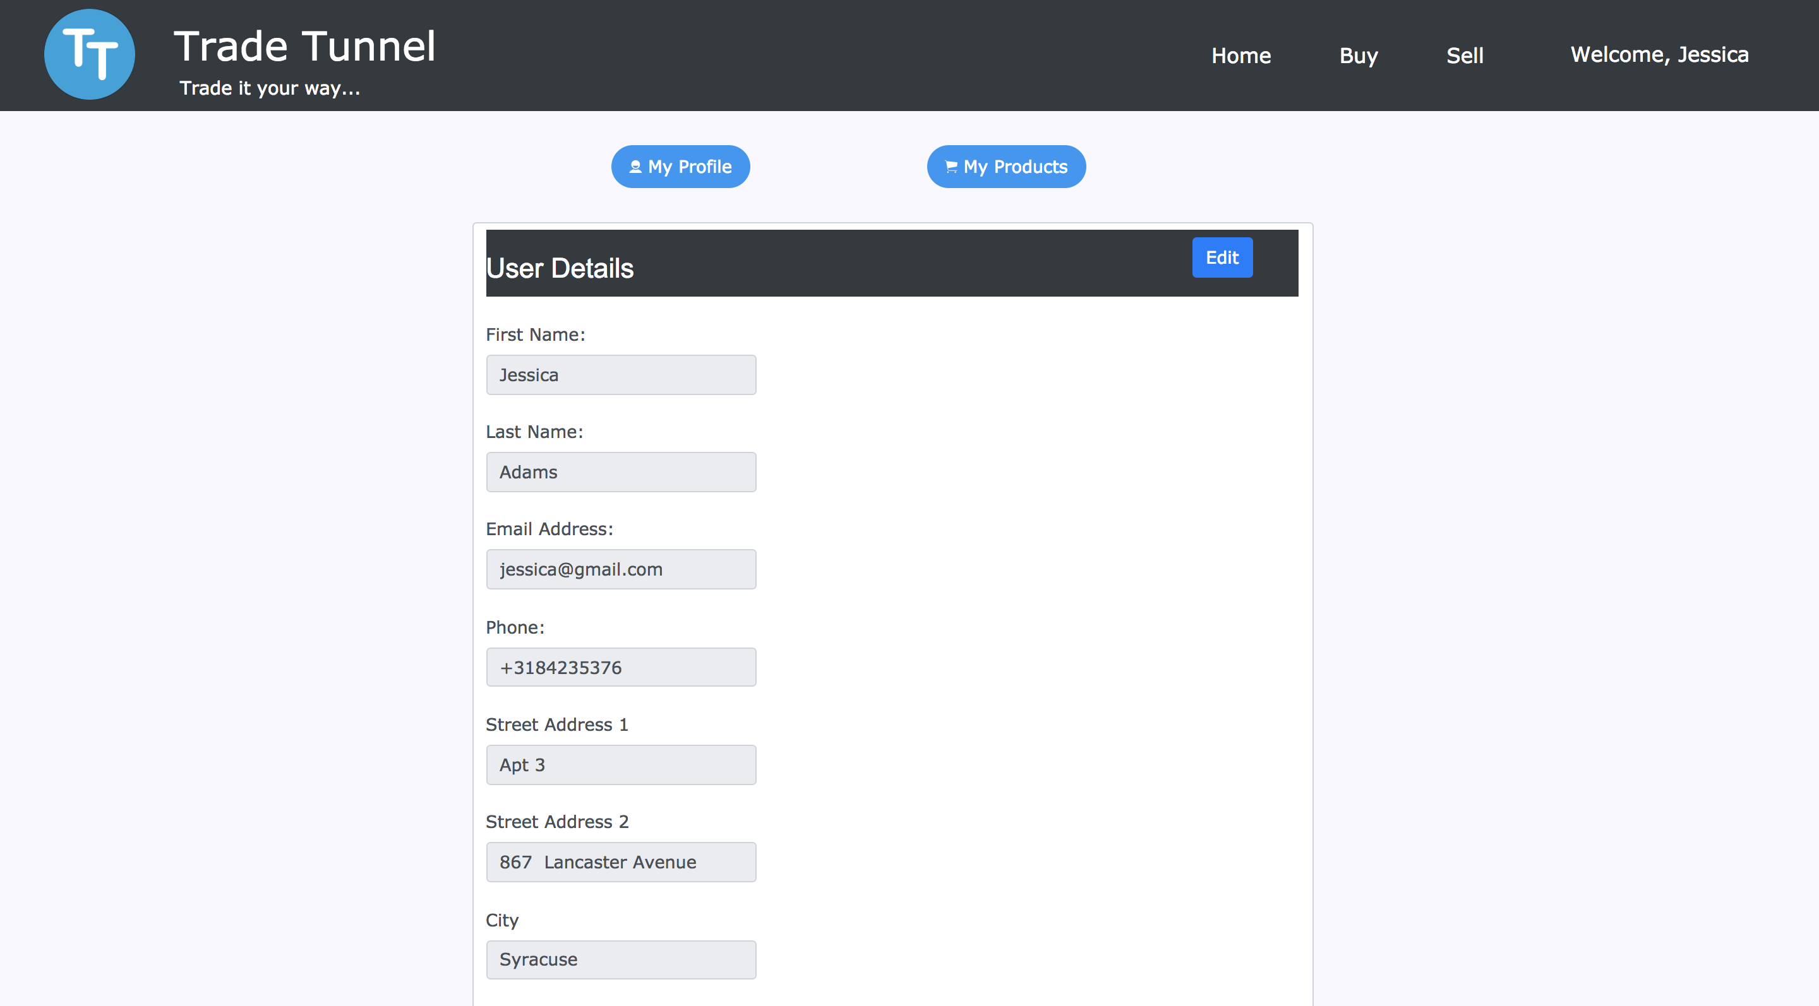

Figure 7.2

* On selecting my products option as shown in figure 7.3, the user can view all its products on the left panel.

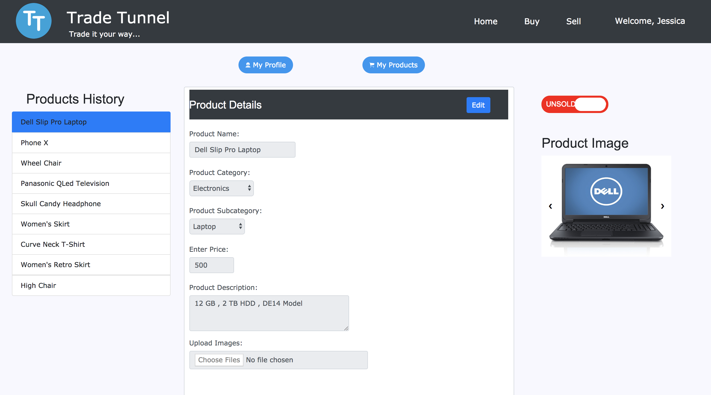

Figure 7.3

* User can click on any of its products and view/update the product information.
* An easy toggle button provided allows the user to update the product status by simply toggling the product status option as shown in figure 7.3

## 8. Logout from the application

* On clicking on the welcome legend as shown in the figure 8.1, the user gets an option to logout of the application and end its current session.

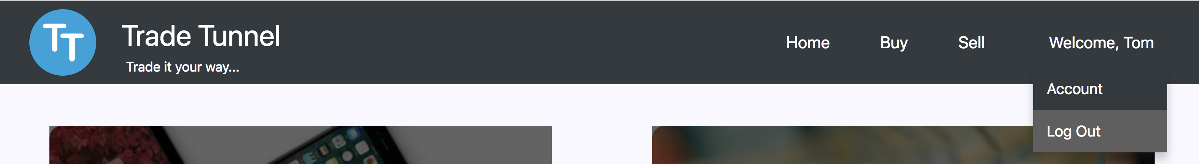

Figure 8.1

Code is available on bitbucket - run the following command to clone the repository - git clone https://anagha03@bitbucket.org/ip_project_/main.git